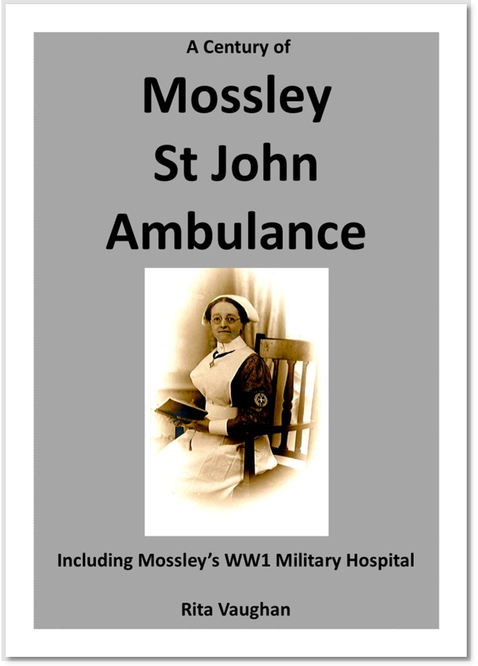The Mossley Branch of the St John Ambulance Brigade was in existence for almost 100 years. During that time they attended virtually all public newsworthy events that occurred in Mossley. By following the story of Mossley St John Ambulance we follow the history of Mossley. The book contains details about: the 1911 tram disaster, the 1912 gas explosion, the 1913 Royal Visit, and the Auxiliary Military Hospital which was set up in 1914 by the Mossley Branch of the St John Ambulance Brigade. During the Great War over 500 patients were cared for at the hospital. The Sister-in-Charge throughout the whole period that the hospital was open was Miss Clarinda Rowbotham. It is Clarinda’s photograph that illustrates the front of the book. Original VAD cards, now held by the British Red Cross, have given us the names and addresses of 38 local women who worked as nurses at the hospital, and these details have been included in the book. Clarinda Rowbotham was the first Lady Superintendent of the Mossley St John Ambulance Brigade, and she held that position for over 50 years. For her dedication and continuous voluntary work Clarinda was awarded the following medals: the Associate Royal Red Cross, the Serving Sister’s shoulder badge, the Defence Medal, and the Service Medal of the Order of St John. Miss Clarinda Rowbotham is believed to be the most highly decorated woman from Mossley. She was also the first school nurse for Mossley, a State Registered Nurse, a Health visitor, and a State Certified Midwife. The story of Mossley St John Ambulance continues with the Second World War, when the Mossley branch ran the First Aid Post at the Temperance Hall on Argyle Street, trained the Air Raid Wardens in First Aid, and provided a First Aid Service to the public Air Raid Shelters in Mossley. The book, which is packed with photographs and stories about the members, finishes when the Mossley Branch of the St John Ambulance Brigade closed. In the near future Blue Plaques are to be placed, by the Town Team, at the site of the Military Hospital and outside the home of Clarinda Rowbotham.
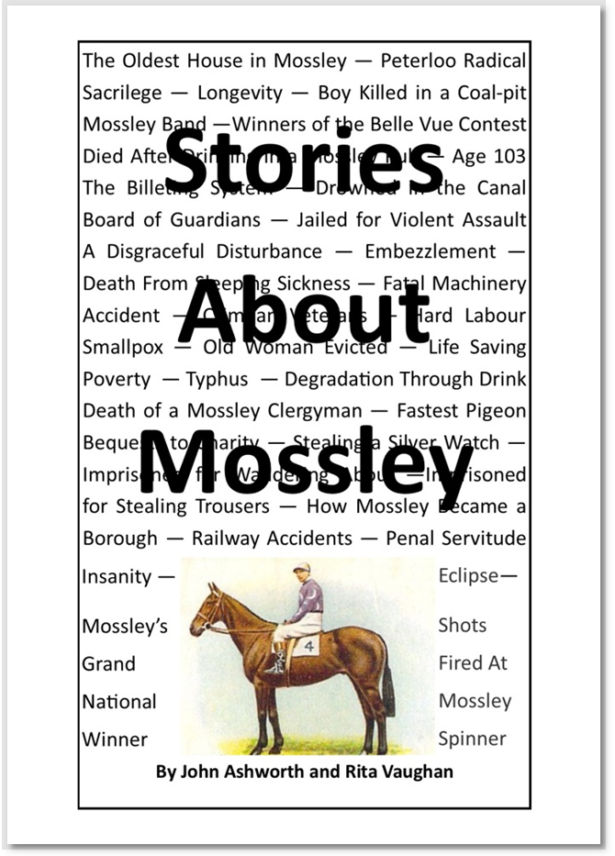

Most of the stories in the book “Stories About Mossley” were originally printed in the newspapers of the day, and a few extra facts from other sources have been added in to give a more interesting version of the events. The authors of this book say that almost all of these stories are completely true book, and can be confirmed by true facts. But “Longevity”, the story about the oldest man in Mossley being 105 years of age, well that, unfortunately, cannot be confirmed. Some other stories in the book may also have an essence of exaggeration as well. This book contains the weird and wonderful stories about: drunken clergymen, deaths from sleeping sickness, the old custom of “uppin”, drownings and lifesaving, the largest egg, the fastest pigeon, the Grand National Winner, famous people born or buried in Mossley, and the true crimes, such as being jailed for stealing trousers or for wandering about. PLEASE BE WARNED: Mossley also had a “horrible history” and all of the gruesome stories about men murdering their wives are included in this book: such as the Weaving Loom Murder, the Man Hung at York For Arsenic Poisoning, the Insane Husband, and the Empire Cinema Murder. The book is not all gloom and doom, the book has been balanced out by having just as many good guys as bad guys. Some of the famous born in Mossley include the Mayor of Oldham and the Lord Mayor of Manchester. Buried at St George’s Church in Mossley are: two men who fought in the “Peninsula War”, John Whitworth whose medals are on display at the Tower of London, and William Nield who formed one of the “forlorn hope”. Also buried at St George’s is Samuel Booth, a man struck with a sabre at Buckton Castle, the order to charge being given by Rev Hays, one of the magistrates who also ordered the cavalry to draw their sabres on the crowd at “Peterloo”. John Knight, one of the organisers of the “Peterloo” rally, was also buried at St George’s.

