

**Wednesday 22 March**

2pm-3.30pm at Tameside Local Studies and Archives Centre,

Central Library, Old Street, Ashton under Lyne OL6 7SG

For both new and experienced family history researchers with military expert Liam Hart

**Researching Your Army Ancestor in World War 1**

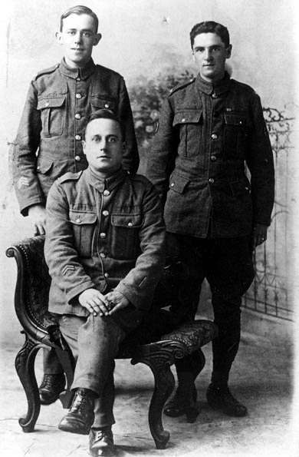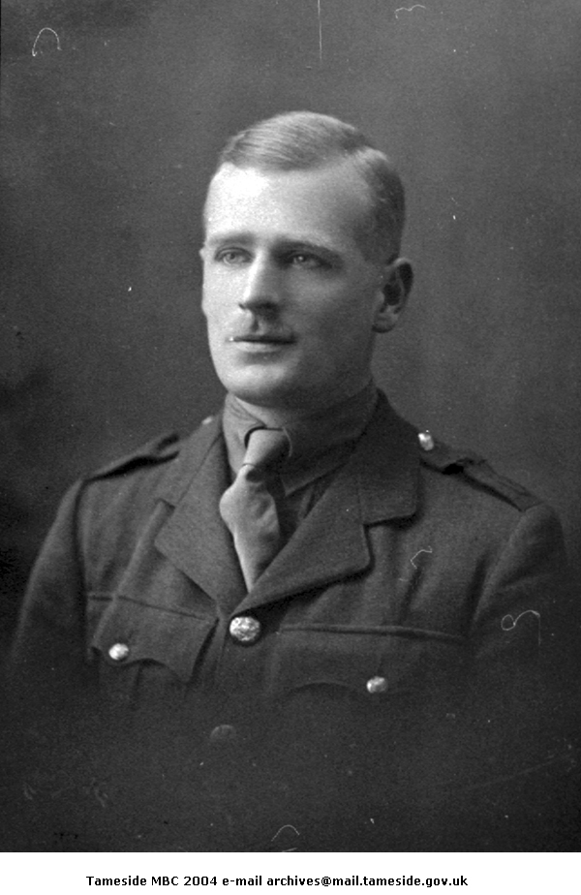

Booking essential on 0161 342 4242 or email archives@tameside.gov.uk

**Free**

