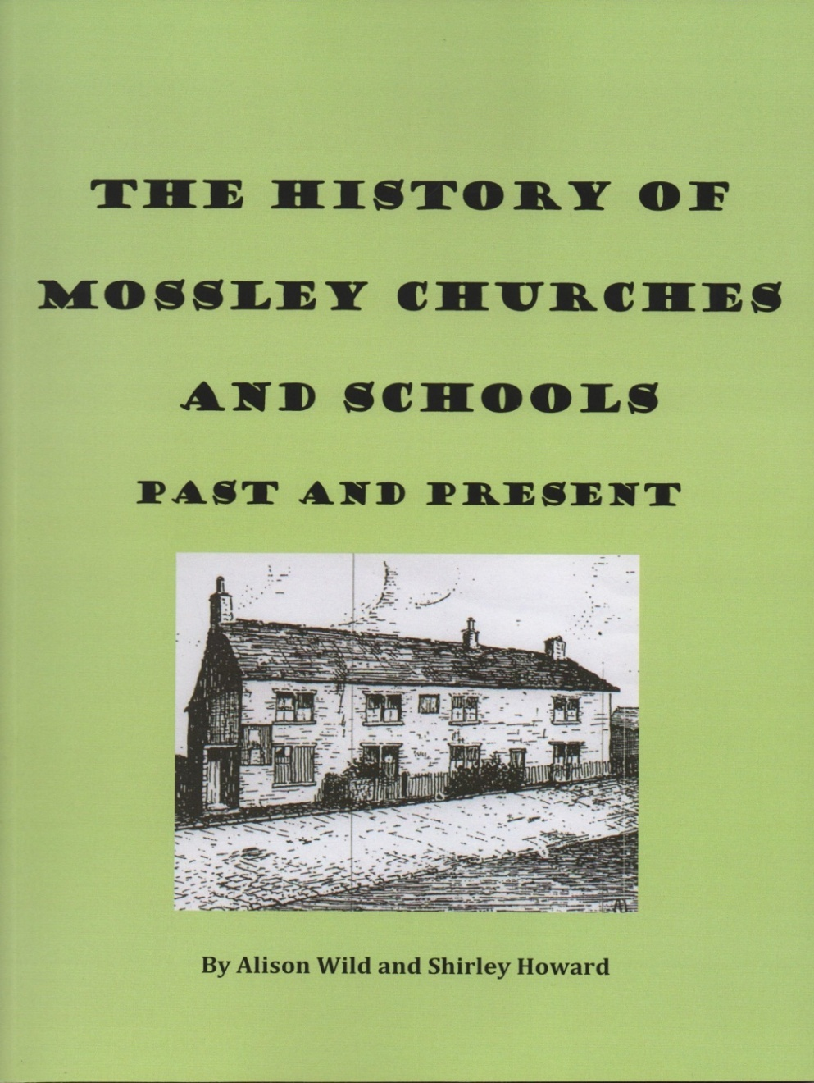
A new book
by
Shirley Howard and Alison Wild will be launched at The George Lawton Hall on Monday 10th October 2016 at 11.00am

